Project Report

**Overview and Summary**

The program utilizes a table of US population data from 2010 to 2019 to calculate the US counties with the largest change in population and to extrapolate the future US population. The user has the ability to choose whether to find the largest change counties or to extrapolate the future population, as well as the range of years or future year for which the program completes the calculations.

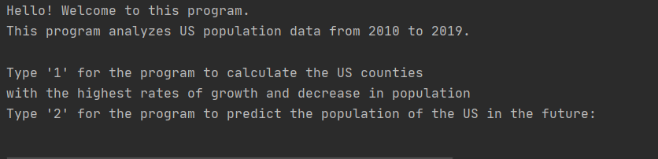

Sample Inputs:

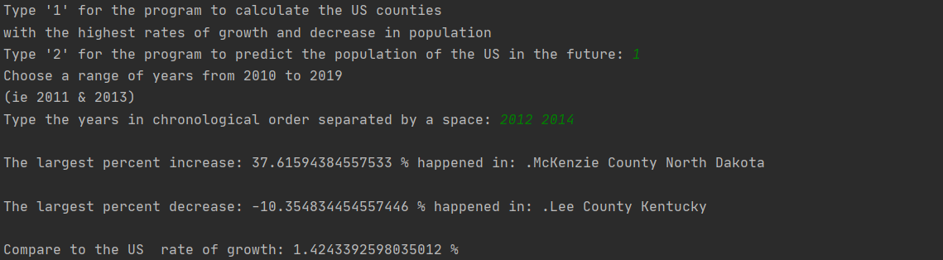

Above: The user enters an input of ‘1’. The program returns the option to choose a range of years from 2010 to 2019. The user chooses the range of years from 2012 to 2014. The program returns the US counties with the largest increase and decrease in population and the percent change in the population of the United States in that same time period.

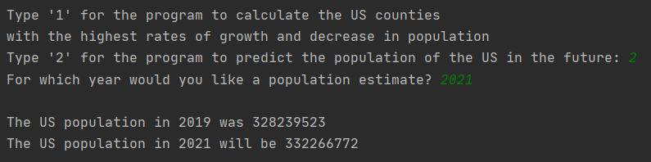

Above: The user enters an input of ‘2’. The program returns the option to choose a year for which the user wants to calculate a population estimate. The user chooses the year 2021. The program returns the US population in 2019 and the US population estimate in 2021.

**Target Audience**

The target audience of this program comprises individuals and organizations interested in analyzing US population data. Finding the fastest growing and depopulating counties in the US allows the user to identify counties that may present the potential for investment or counties in need of economic support. Such a tool could be useful for the US Census Bureau and individuals interested in investing in the fastest growing regions of the US.

**Specific Programming Techniques Used**

* Decision structure - allows the user to choose either the calculation of the fastest growing and shrinking counties or to calculate the future population of the United States.
* String - when a user inputs a year, the year becomes a string. The string is then utilized to determine the column value of a year (counties) or is converted to an integer for calculation purposes (US population).
* If-elif-else statement - determines the code used for either of the two initial decision structure choices. The else clause causes the program to return an error if the user enters an incorrect input. An if-elif-else statement also assigns a number to each year in the county calculation.
* For-loop - all for-loops in the program analyze the population csv by enumerating the number of rows in the file and using the row data to perform calculations.
* User-defined functions -
  + finding_max: calculates the row that contains the county with the highest growth
  + finding_min: calculates the row that contains the county with the largest decrease in population
  + county-enum: determines the name of the county that coincides with the row found in finding_max and finding_min

**Challenges**

A major challenge in the creation of my program was assigning the correct county name to the rows representing the largest changes in population. I had to start the enumeration process from the 4th value in the finding_max and finding_min functions in order to account for skipping the first three rows when the program calculated the change in population for each county. Another challenge in the program was printing the name of the output county and its population change. The function county_enum determined the name of the output county, but I struggled to print the name of the county with its population change. I fixed this by assigning the variable ‘result’ to the returned output of the function county_enum, which I called inside of the functions finding_min and finding_max. I then printed result[0] (the population change) and result[1] (the name of the county).

**Future Extensions**

One feature that would return additional pertinent data would be the calculation of the county with the physical largest increase in population and the physical largest decrease in population. This would display populous counties with the largest population changes in addition to the previous output. Counties with larger populations are more likely targets for investors, as they are easier to support or develop. I would also add the option to choose the type of extrapolation used to predict the future US population. Currently the only variant is a linear calculation based on the average annual growth rate from 2010 to 2019. This situation can be improved by granting the user the option to choose the range of years for which to calculate the average annual growth rate, which would then be used to calculate the future US population. Another solution would be to provide the possibility of a polynomial extrapolation of the future population data, creating a polynomial function from the population change rates for every year from 2010 to 2019.